Installing and configuring Ceph Metrics with the Grafana dashboard

You have used ceph-ansible to set up your cluster, and you can use the same ceph-ansible virtual machine to install cephmetrics to take advantage of the inventory file—/etc/ansible/hosts.

How to do it...

We will use the following commands for configuring Ceph Metrics in ceph-node1:

1. In this book, ceph-ansible virtual machine is ceph-node1. Perform the following steps in ceph-node1. This will install repositories which include the cephmetrics packages and its dependencies.

Copy

**sudo su -**

**mkdir ~/cephmetrics**

**curl -L -o /etc/yum.repos.d/cephmetrics.repo**

**http://download.ceph.com/cephmetrics/rpm-**

**master/el7/cephmetrics.repo**

**yum install cephmetrics-ansible -y**

1. Edit the inventory file.

You need to modify /etc/ansible/hosts to add Ceph Metrics node and in this book, we are using ceph-node1as Ceph Metrics node.  If you are running ansible-playbook on a host mentioned in the inventory file, you will need to append ansible_connection=local to each line in the inventory file that mentions that host.

1. After adding the inventory, the file format looks like this:

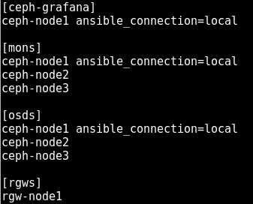

At the time of writing this book, Ceph Metrics was in development mode for CentOS and Ubuntu, and we had continuous enhancement going on for some of its limitations.  Ceph Metrics limitations are listed in the following README screenshot.

This file is present in the ceph-node1 VM path: /usr/share/cephmetrics-ansible/README.md:

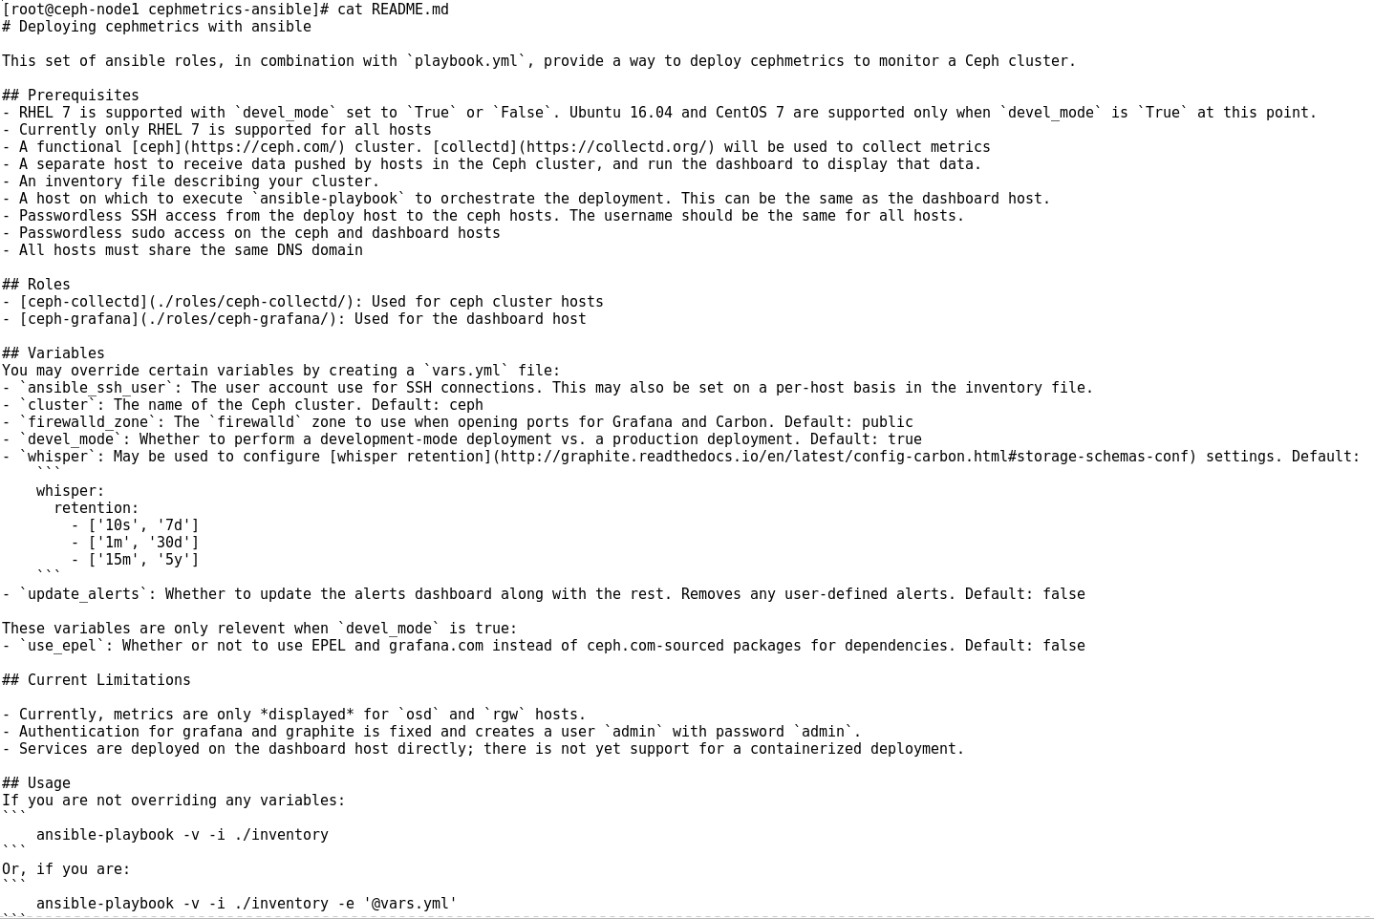

1. For CentOS installation, we need to change the devel_mode and the use_epel from false to true in roles/cephmetrics-common/defaults/main.yml file:

Copy

use_epel: true

devel_mode: true



1. Add the following lines at the top of the roles/ceph-collectd/tasks/configure_collectd.yml filebecause Ceph Metrics is still in development—this was a known issue so we need to do it by manually editing it:

Copy

- name: Set collectd_dir

set_fact:

collectd_dir: "/usr/lib{{ '64' if ansible_pkg_mgr == 'yum'

else '' }}/collectd"

- name: Set collectd_cephmetrics_dir

set_fact:

collectd_cephmetrics_dir: "{{ collectd_dir }}/cephmetrics"

1. Run the Ceph Metrics playbook:

Copy

**ansible-playbook -v playbook.yml**

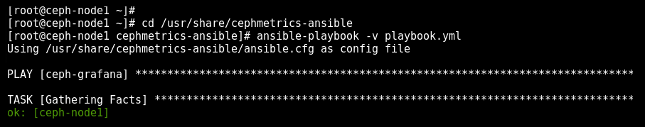

1. Once completed, you will have the following output having dashboard link and username and password:

